**Winter Newsletter**

**A Happy and Healthy Christmas for your Pet**

Now that the Festive Season is almost upon us and we are all rushing around with a million things to do it is important not to forget that Christmas can be hazardous time for our pets.

Take care with floral arrangements and plants especially if you have cats; all Lillies are toxic to cats and the pollen can easily get on their coats if they brush past an arrangement, they can then ingest the

toxins when they groom themselves. Ponsiettas are also a common addition to the home at Christmas they are toxic to your pet if ingested.

Many households hang chocolate treats on the tree or wrap presents containing chocolate and place them underneath the tree. Chocolate is poisonous to dogs and cats it contains a substance called theobromine. Dark chocolate is the worst as it contains a greater concentration of theobromine. Dogs especially are attracted to the smell of chocolate treats. It is important not to leave any chocolate treats in reach of pets, remember to shut them out of the room where the tree is when you go to bed or go out.

Cats love to play with string and tinsel is even more attractive as it sparkles. So again take care not to leave them unattended with the Christmas tree decorations. Tinsel can get stuck in the digestive tract if ingested causing serious problems for your pet and often requiring an operation to remove it. If you have a “real” Christmas tree then be careful to pick up any dropping needles as they can get stuck in your pets paws. Pine trees can also be a cause of skin irritation in pets with skin allergies.

A lot of us like a “tipple” at Christmas, but remember not to leave your glass unattended, as often dogs will “finish off” your beverage, pets have a low tolerance for alcohol and it can damage the liver.

Both grapes and raisins are toxic to dogs. Raisins are also in lots of different foods that we eat such as mince pies and Christmas pudding, so avoid giving your dog anything that might contain raisins. Raisins can cause kidney failure in some dogs.

Ingestion of batteries is more common at this time of year.  If the battery is chewed and pierced it can cause chemical burns and heavy metal poisoning.  If they are swallowed whole it is possible they will cause an obstruction.  All batteries are potentially toxic so if you suspect your dog has chewed or swallowed a battery speak to your local vet.

Hopefully these tips will ensure you and your pet have a safe and happy Christmas!



**Small Furries!**

Small mammals such as rabbits and guinea pigs can find themselves rather forgotten in the winter as we huddle indoors. Due to their small size, they are particularly vulnerable to suffering from the effects of cold weather.

If possible, try and move their hutch indoors (if it is to a garage then it needs to be one that does not also house a car– the fumes will kill your pet).

If this is NOT possible then try to insulate their hutch (but make sure you don’t cover it completely as this will affect ventilation) and provide plenty of extra bedding so they can burrow into it.

They may not want to run around outside, but small pets will still need exercise and playtime. Find a safe space for them to stretch their legs inside and buy (or try and design) some interactive feeders to keep them busy and amused whilst they’re back in their hutch.

If your pets are used to the quiet environment of the garden, then finding themselves in the middle of a busy household inside can be rather stressful for them. Make sure that their hutch is placed in a quiet spot and away from both drafts AND radiators.

Check your pet over thoroughly at least twice a day and don’t hesitate to contact your vet if you have any concerns.

Make sure you also check water bottles regularly and be aware that, whilst you may have a cover for the bottle, this will not stop the spout freezing. You may need to serve the water in a bowl to stop it freezing so quickly.

**A Healthy Dog Biscuit Recipe**

While we are all enjoying treats at Christmas, why not try this simple recipe for delicious dog biscuits to make at home? If your dog has a wheat allergy just replace the flour with rice flour.

Preparation time: 10 minutes

Cooking time: 20 minutes

**Ingredients:**

170g (6oz) flour

170g (6oz) oats

1 tsp baking powder

2 tbsp cooking oil

2 tbsp honey

2 tbsp peanut butter (the no added sugar kind)

2 eggs

**Method:** Heat the oven to 180°C (350°F), Gas Mark 4. Grease and line a large baking tray. Mix all the ingredients together to form a dough, roll it out and put it onto the tray right up to the edges. Cut the dough into biscuit sized sections with a sharp knife. Bake on the middle shelf for about 20 minutes, turn off the heat and leave them in the oven to dry.



**Birthday Celebrations**

**About Town and Country Veterinary Group**

Town and Country Veterinary Group was founded in 1987, initially based at our Rubislaw practice in Aberdeen. In 2017 we are proud to announce that we will be celebrating 30 years of providing quality animal care in Aberdeen and Aberdeenshire. The practice was founded by Chris Wiper MRCVS, with senior partner Liz Geraerts, and quickly outgrew the Rubislaw site, expanding to six surgeries, four of which are in and around Aberdeen, and two of which are in Aberdeenshire.

Town and Country Veterinary Group is a 100% small animal practice. Three of our branches are RCVS approved Tier 2 clinics with facilities for dogs, cats and exotic pets. We offer a wide range of surgical and medical services, including orthopaedic and soft tissue surgery, dental work, radiography, ultrasound and endoscopy. We have in-house laboratory facilities enabling us to handle biochemistry and haematology work, parasitology, urine and faeces samples and to have the results back the same day. We also offer a range of free nurse clinics including puppy and kitten clinics, weight clinics and dental checks. The nurses run regular puppy parties and are always helpful with dietary advice for all pets.

All our branches offer microchipping and help with the PETS Passport Scheme for travelling with your pet. We also offer a referral service for Acupuncture, Dermatology, Ophthalmology and Physiotherapy.

**30 years of Town and Country Veterinary Group**

Throughout 2017 there will be a variety of events and promotions to celebrate our anniversary. Details will be posted regularly on our Facebook page and in your local branch. We hope you can join us in our celebrations and look forward to seeing you and your pets in the coming year.

**Town & Country Own Brand Natural Therapies**

Town & Country Veterinary Group now stocks its own range of natural therapies.

There are products for both dogs and cats, including Calming Aid in tablet or liquid form, Joint Aid in a variety of sizes, Bladder Aid and Liver Aid tablets for Cats, Dental Aid toothpaste and EFA Aid (Essential Fatty Acids) to help support skin and joint care. The products are premium quality, veterinary developed formulations containing the best quality ingredients, and can be requested by asking at Reception.

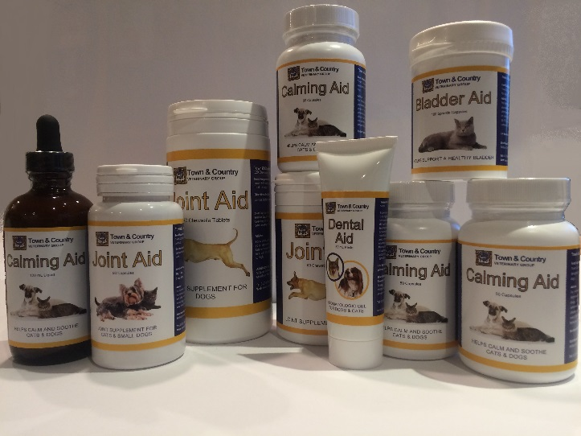

**Don’t Forget The Wildlife!**

Putting out bird food will help wild birds when natural food supplies are scarce. Cat food can be left out for any struggling hedgehogs or other wild mammals.

Bowls of water can be left out for wild animals, when natural water supplies are frozen

Finally, take care on the roads! Many wild animals are driven to venture closer to towns during really bad weather and you are more likely to come across them on the roads in winter. Some are even attracted by the salt grit we put on our roads during freezing weather.

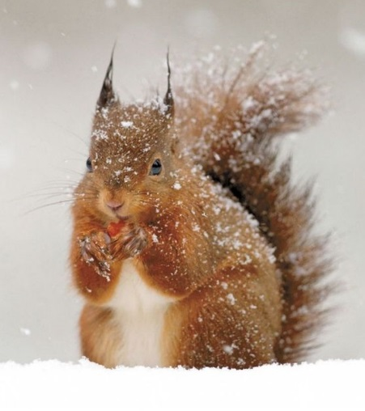

**Extras**

We stock a wide range of foods and accessories including Hills Vet Essentials, Royal Canin and dog and cat toys and accessories, dog leads and muzzles, shampoos and grooming equipment. If you have a particular item in mind, please speak to one of our receptionists as most items can be ordered on a 24 to 48-hour basis. We can also provide prescription only medicines for your pet, where appropriate, with a minimum of 24 hours’ notice.

**Contact Us**

You can find us on social media! Search for our Facebook page Town and Country Veterinary Group or follow us on Twitter @townandcountvet.

If you would like us to publish photos of your pet or would like to let us know about a lost or found animal, please email us at [office@townandcountryvet.co.uk](mailto:office@townandcountryvet.co.uk)

**Festive Opening Hours**

**December 2016 January 2017**

Sat 24th Dec: 10am – 5pm Sun 1st Jan: 10am – 1pm

Sun 25th Dec: CLOSED *(Kingswells emergencies only)*

Mon 26th Dec: CLOSED Mon 2nd Jan: CLOSED

Tue 27th Dec: 10am – 12pm Tue 3rd Jan: 10am – 12pm

*(Kingswells & Banchory only) (Kingswells & Banchory only)*

Wed 28th Dec: Open as usual Wed 4th Jan: Open as usual

Thu 29th Dec: Open as usual

Fri 30th Dec: Open as usual

Sat 31st Dec: 10am – 5pm



**And Finally….**

The staff at Town and Country Veterinary Group would like to wish all our customers, both clients and animals, a happy and healthy Christmas and New Year!

