

**PUPPY PARTIES**

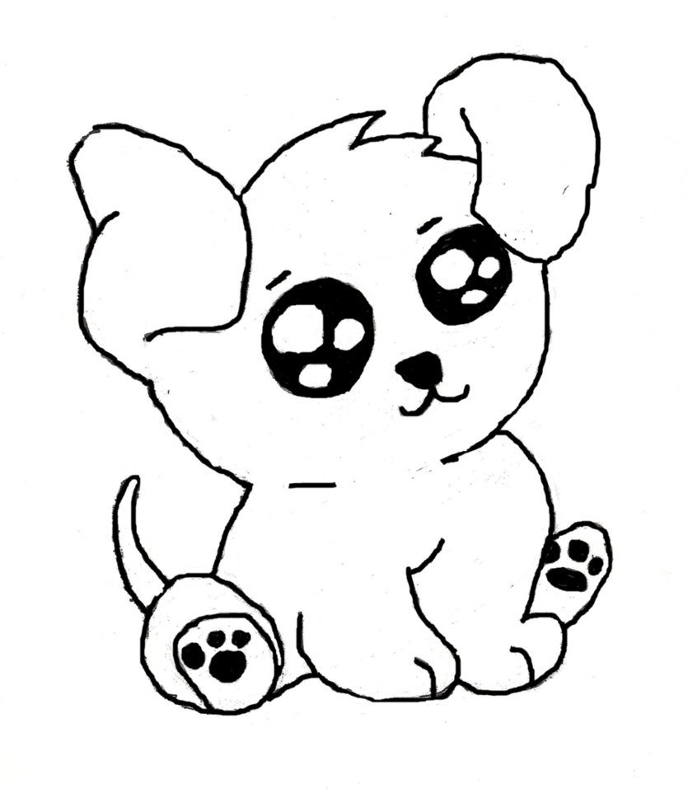 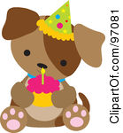 

Free puppy goodie bag

Demonstrations on Health Checks

Advice on toileting & training

Playtime/Puppy Socialisation

Communicate with other owners

Free to attend

If you would like to attend please call us at one of the below surgeries

**Westhill** **Millburn** **Bieldside**

Unit 24, Westhill Shopping Centre Millburn Cottage 91 North Deeside Road

Old Skene Road Millburn Street Bieldside

Westhill Aberdeen Aberdeen

AB32 6RL AB11 6SS AB15 9DS

Tel. 01224 741685 Tel. 01224 588770 Tel. 01224 861161

**Kingswells** **Rubislaw** **Banchory**

Kingswells Village Centre 5 Rubislaw Park Road 14a Bridge Street

Kingswells Aberdeen Banchory

AB15 8TG AB15 8BX AB32 5SX

Tel. 01224 749191 Tel. 01224 311555 Tel. 01330 822648

(Please note puppy parties are currently only held at Millburn, Bieldside and Westhill)