**Autumn Newsletter**

Fireworks and Pet Safety

As November approaches, the Scottish SPCA is issuing its annual warning that fireworks can have a serious impact on the welfare of animals.

We are reminding people to bear in mind that fireworks season can be a very stressful time of year for pet owners who are trying to protect their animals from the fear and distress they can cause.

To help protect your pet from injury or even from developing long term behavioural problems here are some top tips:

* Avoid leaving your pets alone – they will feel safer with you around
* If your pet starts feeling anxious stay calm and act normally. This will help your pet feel safer and lets them know there is nothing to fear.
* Keep your cat or dog inside, and keep all windows, curtains and doors closed.
* Turn on the TV or some music to drown out some of the noise
* Provide your cat with a litter tray if it is used to being able to get out in the garden
* Make sure your pet is wearing some form of identification. If they manage to escape this will make sure you can be easily contacted when your pet is found. Microchips are excellent but remember to ensure your details are up to date on the chip database. However, they do not replace collars which are useful for restraining an anxious dog as well as identification.
* Ensure that any collars are safety collars so your pet doesn’t hurt itself if it gets caught on other objects. Reflective collars are also a good idea.
* Take your dog for a walk during daylight, when fireworks are less likely to be set off.

With rabbits and smaller animals, it is recommended that owners:

* Bring the hutch or cage inside to a quiet room, garage or shed
* If you cannot move it, turn it away from the open garden to face the house, cover it with thick blankets or a quilt so your pet isn’t able to see the flashes and provide them with extra bedding so they can hide away

Not all pets are affected by fireworks but if you’re not sure whether your dog is stressed by fireworks, the symptoms may include some or all of the following:

* Salivating and drooling
* Trembling and shaking
* Scratching to get into the house or out of a room
* Hiding in corners or under furniture
* Whining, barking or howling
* Whimpering and excessive or abnormal attention seeking
* Loss of bodily functions – bladder and/or bowel
* Refusal to eat

If you are unsure of your pet’s behaviour or you know your pet is stressed

by fireworks, please seek veterinary advice well before fireworks season.



Staff News

Since the last newsletter there have been lots of exciting developments among our staff members!

We would like to congratulate Sarah McLean, our HR Manager, and Sarah Chesterman, vet at our Rubislaw practice, on their respective weddings, and wish our Kingswells vet Gemma Insley the best of luck as she departs for maternity leave.

Congratulations also to Sam Lang who is now a RVN at our Kingswells branch having completed her training.

Good luck also to Chloe Fraser who is leaving us to start her dream qualification as a marine biologist, we will be sorry to see her go but hope she has an amazing time!

We have also said farewell to Sheila Anderson, who took over from Shirley as our new office administrator, and has returned to the field of business travel. She has been replaced by Michelle Brown who joins us from Kemnay Academy.

Pet Health Plan

Town & Country Veterinary Group has its own Premier Health Plan for dogs, cats and rabbits, provided by Denplan Pet Health Plans.

The plan is paid monthly by direct debit, with the cost dependent on the type and size of pet you have. The plan covers the cost of annual vaccinations, a six monthly health check, annual supply of wormer and flea treatment and up to 15% discount off the cost of some other services and products.

This amounts to great savings over the year, and ensures that your pet gets the regular care and health prevention treatment it needs to stay in the best possible condition. The plan is open to new and existing clients, and further information can be obtained from the Receptionist at your local branch or by speaking to your vet.



Puppy Parties

Town and Country Veterinary Group runs regular puppy parties

at our Bieldside, Millburn and Westhill branches.

Owners can receive:

Advice on toileting and training

Demonstrations on how to check their puppy’s health

Playtime and puppy socialisation

A free goody bag containing food samples

This is an excellent opportunity for puppy owners to

come along and chat with other owners and with veterinary

staff, and share tips and advice on how to look after the newest

addition to the household!

For further information and the date of the next puppy party,

speak to your vet or the Receptionist at your local branch,

who will be happy to advise when and where the next session will take place.



Autumn Alert – Keeping Your Pet Healthy!

With the onset of cooler Autumn weather, you may be tempted to start dropping

your guard against ticks, but did you know that the late summer and early autumn is

*the* peak time for pesky parasites such as ticks!

Ticks are generally found in areas of woodland, heathland and grassland, waiting

for an animal or human to brush past them so they can jump on and feed.

They attach using their mouthparts and will feed on blood from their host for several

days before finally dropping off.

Unfortunately, ticks can cause problems in two ways; firstly, they can sometimes cause a marked tissue reaction at the attachment site. Secondly ticks can carry infectious diseases which can be transmitted to pets and humans. The most common one is Lyme Disease, though pets travelling abroad may also come into contact with ticks carrying other diseases such as Ehrlichiosis and Babesiosis – all very serious infectious diseases.

**What should I do if I find a tick on my pet?**

In order to minimise the disease risk, it’s a good idea to remove ticks as quickly as possible without leaving the mouthparts in situ. Specially designed tick removers that remove the tick by rotation are very effective.

Never pull or squeeze the tick. Instead, using a hooked tick remover, slide the v-shape under the tick and remove it with a twisting action.

In order to minimise the risk of tick borne diseases, regular preventative treatments will both kill ticks and also help repel them. Additionally, it’s a good idea to routinely check your pet’s coat for ticks. If you find a tick, removal is best attempted with a

specially designed tick remover. Please let us advise you on the best tick control treatment for your pet!

As well as ticks there are a range of other parasites and issues for our pets to contend with at this time of year.

**Fleas** are present in huge numbers in early autumn, so do remember to keep treating your pets!

**Harvest mites** are also active in long grass in the late summer and autumn and will swarm onto passing pets where they tend to congregate on the ears, eyelids, feet and underside of the abdomen. They are easily identified as *bright orange dots* adhering tightly to the skin and are usually a cause of great irritation. Like fleas, harvest mites can also bite humans!

**Autumn aches –** with the cold dark nights coming, it’s important to ensure you make time for walking your dog or his mobility (and yours!) can suffer. Affected pets may show signs of joint stiffness, particularly after rest. It’s also a good idea to keep an eye on your pet’s weight, since it’s all too easy for pets to gain a few extra pounds in the autumn and winter months. If you are at all concerned, please book your pet in for a check-up.

**Autumn toxic hazards**

Many car owners top up their car radiators with antifreeze (containing ethylene glycol) at this time of year.

Any spillage is palatable to pets and even small amounts can cause

kidney failure and death.

Autumn fruits such as conkers and apples will cause digestive

upsets so avoid dogs getting access to them.

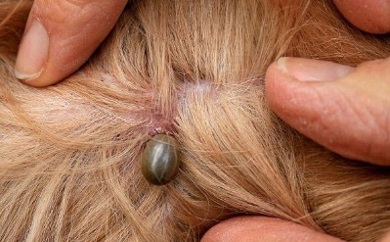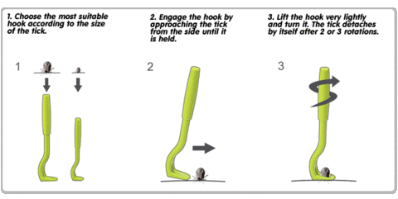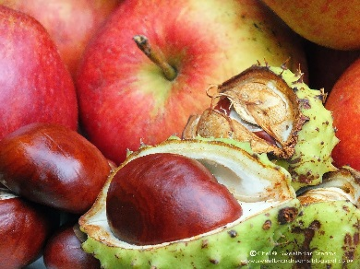

The Benefits Of Having Your Pet Neutered!

Did you know that in addition to preventing unwanted pregnancies, there are many other health and behavioural benefits to having your pet neutered?

**Dogs:** Female dog, heat periods (or seasons) usually occur twice a year and last about three weeks. During this time your dog will be receptive to the advances of un-neutered male dogs in your area. In both sexes, the urge to mate can lead to roaming, becoming lost or getting involved in fights.

**Cats:** Female cats come into heat as often as every two weeks during the breeding season (in the spring and summer months) and will endlessly try to escape to mate with local tom cats. Male or Tom cats, particularly if not neutered, will mark their territory by spraying objects inside and outside the house with strong smelling urine. In addition, they are frequently involved in fights,

resulting in bite injuries and the risk of acquiring deadly viral infections. Sexual contact can also lead to the transmission of viruses as well

In female cats, neutering (termed spaying) involves removing the ovaries and uterus under a general anaesthetic. As well as preventing seasons and unwanted pregnancies, spaying also removes the possibility of uterine infections. It also greatly reduces the risk of developing mammary tumours later in life.

In male cats, neutering (termed castration) involves removal of both testicles under a general anaesthetic. Neutering makes male pets less likely to stray, and in dogs can be of help in controlling excessive sexual drive and with certain types of behavioural problems. Neutered male cats are far less likely to get into fights and spray urine against walls etc.

**Rabbits:** As well as preventing unwanted pregnancies, rabbits can benefit from neutering as this makes them generally a lot calmer and can be more easily kept in social groups without fighting. Spaying rabbits also reduces the risk of uterine cancer which is common in older un-spayed females.

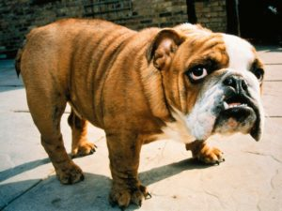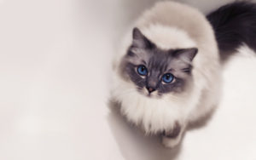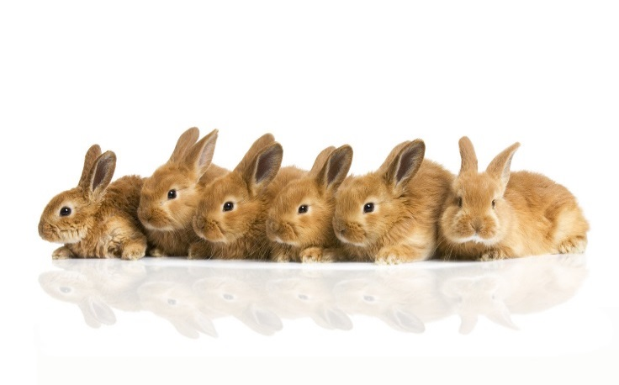

Rabbit VHD Vaccine

Following the recent outbreak of Rabbit VHD (Viral Haemorrhagic Disease) virus we are pleased to announce that a new vaccine is now available on request. Please contact your local branch for further details.

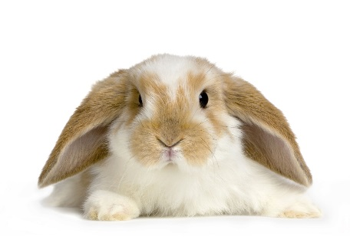

World Animal Day

October 4 is World Animal Day. Find events near you, or find out how you can get involved, at www.worldanimalday.org.uk

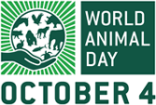

Contact Us

You can find us on social media! Search for our Facebook page Town and Country Veterinary Group or follow us on Twitter @townandcountvet.

If you would like us to publish photos of your pet or would like to let us know about a lost or found animal please email us at:

[office@townandcountryvet.co.uk](mailto:office@townandcountryvet.co.uk)

Extras

We stock a wide range of foods and accessories including Hills Vet Essentials, Royal Canin and dog and cat toys and accessories, dog leads and muzzles, shampoos and grooming equipment. If you have a particular item in mind, please speak to one of our receptionists as most items can be ordered on a 24 to 48-hour basis.

We can also provide prescription only medicines for your pet, where appropriate, with a minimum of 24 hours’ notice.

